
History: Our focus project this term is ‘Childhood’. We will compare everyday life, families and childhood today with those of the 1950s, exploring how and why they have changed over time. We will also learn about a significant event from the decade: Queen Elizabeth II’s coronation in 1953.
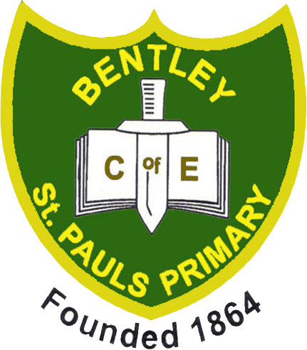
Childhood
Geography: This term, we will explore the project ‘Our Wonderful World’, developing key geographical skills and knowledge. We will learn about human and physical features, maps, compass points and positional and directional language. We will also explore hot and cold places around the world, considering how a country’s location can affect its climate.

Finally, we will focus on the United Kingdom, learning the countries that make up the UK and exploring the different types of settlements found within them.

English: In our first unit, we will learn how to write labels, lists and signs, using texts such as Not a Stick by Antoinette Portis and Billy’s Bucket by Kes Gray and Garry Parsons. These texts will also be used to spark our imaginations and support us in creating fun and engaging descriptions using nouns, adjectives and verbs.

In our second unit, we will explore stories with a repeating pattern, including We’re Going on a Lion Hunt by David Axtell, Handa’s Hen by Eileen Browne, Bringing the Rain to Kapiti Plain by Verna Aardema and No Thank You, a reference text. These stories will support us in developing our sequencing and retelling skills, before creating and writing our very own repeating pattern stories.

In our third unit, we will explore humorous poetry through texts such as Oi Frog! and Oi Dog! by Kes Gray and Jim Field, alongside Animal Upsets, a reference text. The joy and laughter from these texts aim to grow an enjoyment for poetry and will begin to develop our reading and comprehension skills along with stimulate our own writing. Within this unit, we will also explore syllables, the prefix ‘un-’ and the suffixes ‘-ing’ and ‘-ed’, developing our understanding of word formation and past and present tense.

Finally, we will explore stories with familiar settings, including Five Minutes’ Peace by Jill Murphy, Knuffle Bunny by Mo Willems and Boris and Sid Make a Mess, a reference text. Through engaging activities based around each story, we will develop our understanding of familiar settings and use these ideas to inspire and support our own story writing.
PSHE: In our first half term, we will explore the theme ‘Being Me in My World’ through the question, ‘Who am I and how do I fit?’ We will explore what it means to feel special, safe and a sense of belonging, while developing our understanding of rights and responsibilities, as well as rewards and consequences.

In our second half term, we will explore the theme ‘Celebrating Difference’. We will learn about respecting similarities and differences, developing our understanding of anti-bullying and exploring the importance of celebrating what makes each of us unique and special.

Design Technology: This term, we will explore the project ‘Shade and Shelter’. We will learn about the purpose of shelters and explore the different materials that can be used to construct them. We will follow the full design process, from designing and building to testing and evaluating our own shelters for a specific purpose.
Physical Education: In our first half term, our indoor focus will be ‘Fundamentals’, while our outdoor focus will be ‘Invasion Games’. The Fundamentals unit will develop a range of core movement skills, both individually and in combination, while encouraging children to work independently and collaboratively. Invasion Games will introduce a range of team sports, developing children’s understanding of how games are played and how their individual actions can influence the game.

In our second half term, our indoor focus will be ‘Dance’, while our outdoor focus will be ‘Ball Skills’. The Dance unit will explore counting to music and using this to sequence travelling actions, movements and balances to create short dance phrases. Ball Skills will build on core skills, developing children’s confidence, coordination and control when working with a ball.
Music: In our first half term, we will explore the musical spotlight ‘Rhyming in Time’. This unit will focus on rhythm, movement and vocal exploration through the song Rhyming in Time. We will develop our understanding of beat, time and tempo by moving in time with the music, singing and experimenting with a variety of voices and vocal sounds.

In our second half term, we will explore the musical spotlight ‘Let’s Start Singing’. This unit will encourage creative expression, confident singing and ensemble skills, providing opportunities for us to develop our singing and performance skills and share our musical achievements with an audience.

Computing: In our first unit, we will explore Purple Mash, developing essential computing skills through a range of activities. We will learn how to use 2Dos, save our work and navigate key areas of the platform.

In our second unit, we will develop our mouse, keyboard and basic computing skills through creative tools. We will use 2DIY to paint, create jigsaws and design simple drag-and-drop games.

Finally, we will explore how software can be used to group and sort objects, developing our understanding of how data can be organised and interpreted. We will also collect simple data and present it using a pictogram.
Maths: Our first unit will focus on place value, where we will revisit and consolidate our understanding of counting, comparing and ordering numbers within 10.

We will then move on to addition and subtraction, developing our number knowledge through exploring part-whole models, number sentences, fact families and problem-solving within 10.

Finally, we will explore shape, revisiting 2D and 3D shapes and developing our understanding of their names and properties. We will investigate different ways of grouping shapes and use them to create and explore patterns.
Religious Education: In our first unit, we will explore ‘Philosophy’ through the question, ‘How did the universe come to be?’ We will explore creation stories from Christian and Hindu traditions, while also considering non-religious ideas about the origins of the universe. Through our discussions and enquiries, we will begin to consider the different ways people understand how the universe began.

In our second unit, we will explore ‘Human and Social Science’ through the question, ‘How does a celebration bring a community together?’ We will learn about how Christian and Hindu communities celebrate important traditions and festivals, exploring how these celebrations bring people together and strengthen a sense of community.
Reading for Pleasure Authors: Floella Benjamin and Mem Fox
Art: In our first half term, we will explore the project ‘Mix It’. We will develop our understanding of basic colour theory by investigating colour mixing, exploring the colour wheel and observing how artists use colour to create different effects and moods within their artwork.

In our second half term, we will explore ‘Funny Faces and Fabulous Features’. This project will introduce us to the concept of portraiture and explore how different materials and collage techniques can be used to create expressive and imaginative portraits.

Science: In our first half term, we will explore the project ‘Everyday Materials’. We will investigate how objects are made from different materials, including both natural and human-made materials. We will explore the different properties of these materials, carry out a range of experimental tests, and develop our skills in grouping and sorting materials according to their properties and characteristics.

In our second half term, we will explore ‘Human Senses’, delving into the human body and learning about different body parts and how they can be similar and different between individuals. We will investigate our five senses and explore the important role they play in helping us to understand and respond to the world around us, including how they help to keep us safe.

Memorable Experience: Den Building at Thorndon Park (TBC)

